**Project Team 27**

Sprint #1

Week #4

Team Member Name – Swapnil Makarand Joshi

What I did since the last week scrum?

1. Completed landscape creation learning

What I plan to do next week?

1. Start class diagram creation for sprint 2
2. Write a user story for sprint 2

What blockers I have?

None

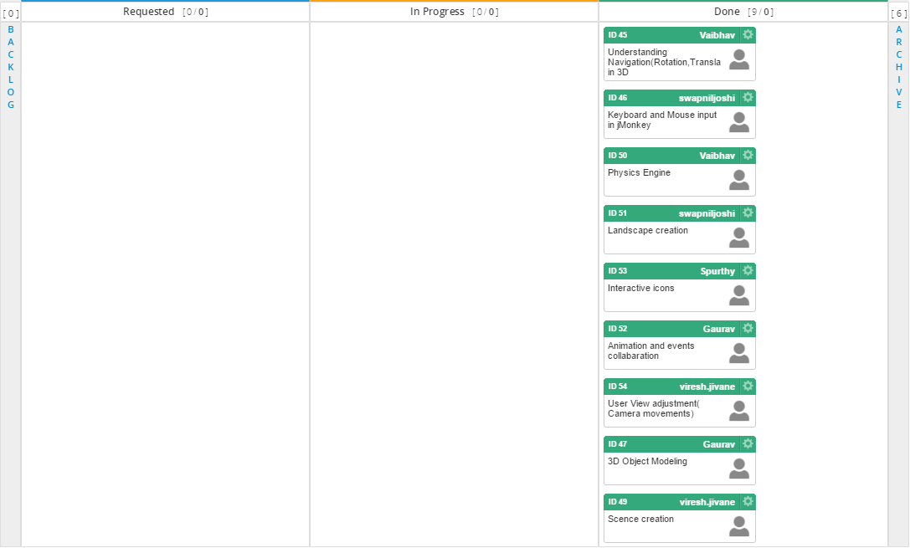

Task board in Kanbanize

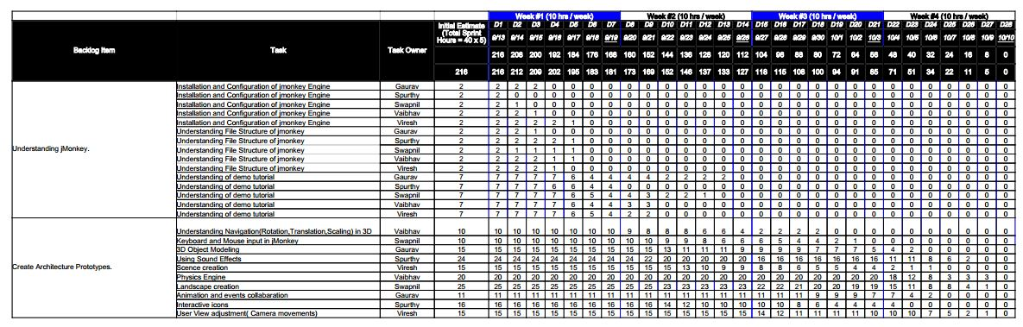

Weekly Standup Report

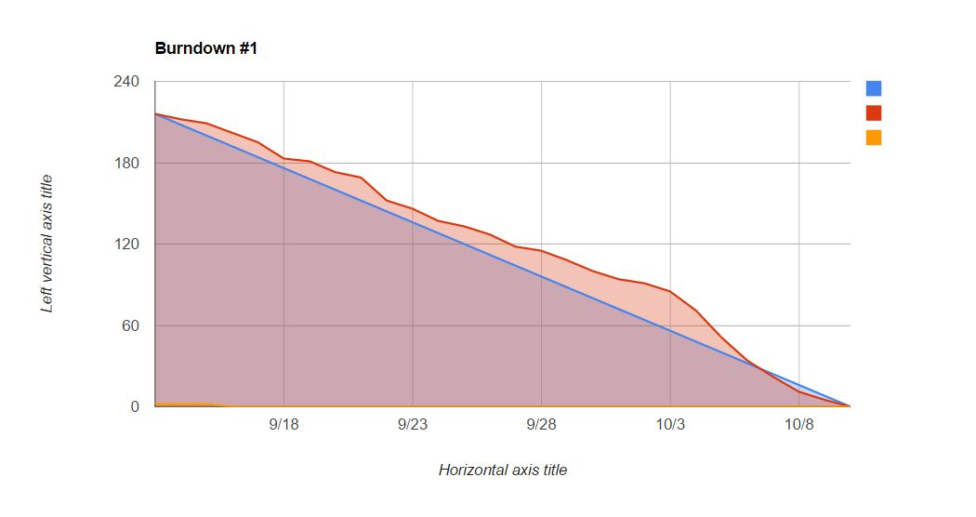

Burndown Chart